Pumpkin Launchers

STUDENT TARGETS
- Skill: I will move with my classmates to send objects upward.
- Cognitive: I will learn about force with my teammates.
- Fitness: I will stay actively engaged throughout the activity.
- Personal & Social Responsibility: I will share equipment safely with my classmates.

EQUIPMENT & SET-UP | 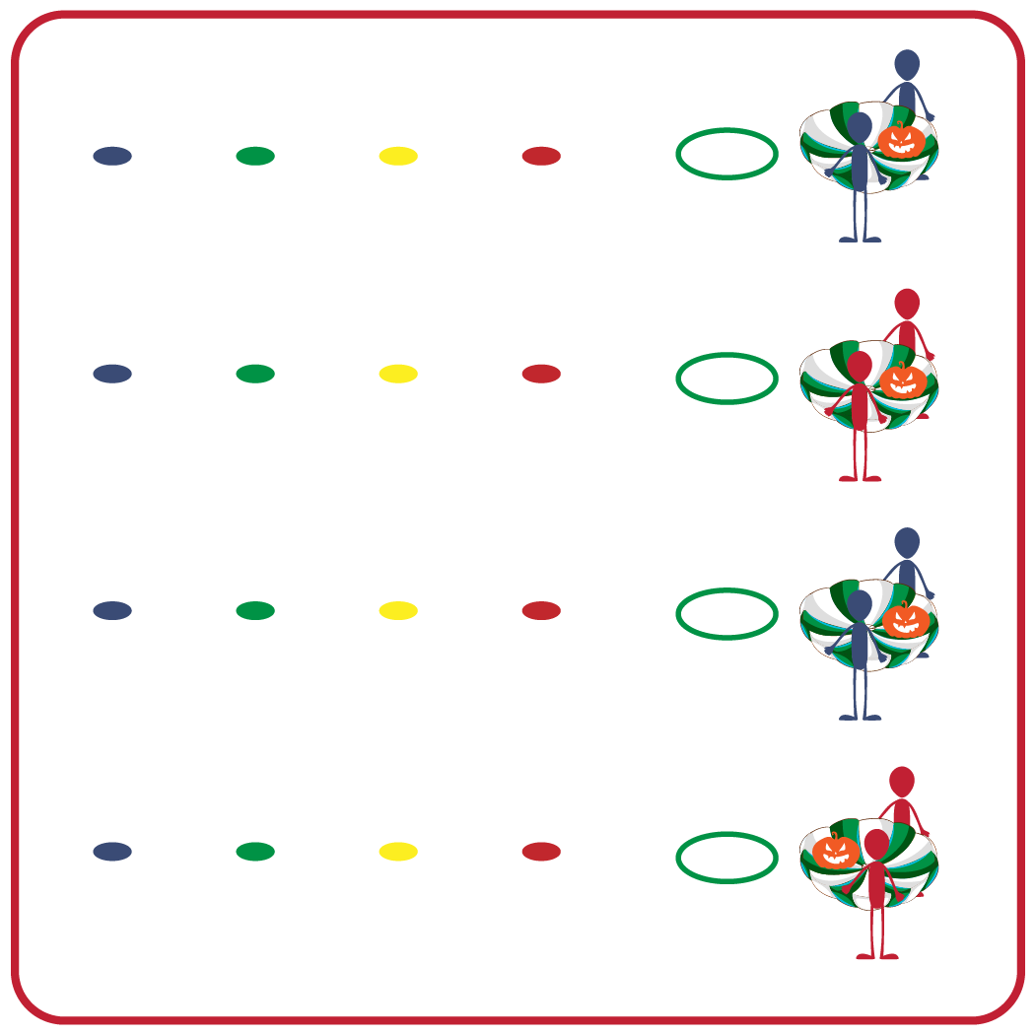
Equipment:
- 1 partner parachute per group
- 1 hoop per group
- 1 foam ball per group
- 4 spot markers (red, yellow, green, blue) per group
Set-Up:
- Create a starting line with a hula hoop, parachute, and foam ball along one side of activity space.
- Place students into groups of 2–4; each group begins at a hoop with 1 ball and 1 partner parachute.
- Measure 4 distances from the hula hoop, each distance marked with a colored spot. Place each of the colored spot markers 5 feet apart.
- Designate a point system for each of the spot markers and display that for students. (e.g., red = 1 point; yellow = 2 points; green = 3 points; blue = 4 points).
ACTIVITY PROCEDURES
- It’s time for our Pumpkin Launchers! The object of the game is for each team to learn about force as they launch their pumpkin back into the Pumpkin Patch.
- On the start signal, each student in your group will hold the handles of the partner parachute, balancing their pumpkin (foam ball) on top of it. Each teammate must be holding onto the parachute for the launch.
- Your group will work together to launch the pumpkin (foam ball) back into the pumpkin patch!
- Your team will get points for each successful pumpkin launch that is completed. Teams will see how many successful pumpkin launches can be completed in 2 minutes.
- A successful pumpkin launch is when the pumpkin travels in the air past your hoop and past at least the first spot marker. You earn points according to how far your pumpkin was launched. (Teacher Note: see “Set-Up” bullet above for example of how to designate points).
- Alternate sending one teammate to retrieve your pumpkin and bring it back to your group after each launch.
- Each team needs to remember to keep everyone safe by working together as a group and communicating with their teammates as you launch and retrieve your pumpkins.

DEBRIEF QUESTIONS
- DOK 1: What does it mean to be safe?
- DOK 2: What was something your team did to stay safe during this activity?
- DOK 2: Why is it important to follow directions and safety procedures during physical activities?

PRIORITY OUTCOMES
Personal Responsibility & Safety:
- Grades K-2: Follows directions for safe participation and proper use of equipment without reminders.
- Grades 3-5: Works independently and safely in physical activity settings.

