Ghost Boo-ling

- Begin at a spot marker and take turns with a partner rolling the ball to knock over the Ghosts!
- Each partner gets two tries to knock down all of the Ghosts (bowling pins).

- Be a good partner and help get the ball back to them after each attempt.
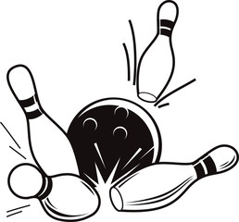

Haunted Hurdles

- Begin at a spot marker and jump over each of the haunted hurdles!
- Be careful not to touch them – they are haunted after all!
- See how many times you can jump over ALL the hurdles.

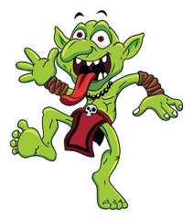
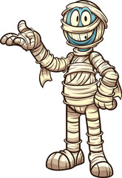


Trick or Treat Toss

- Begin at a spot marker and take turns with a partner tossing the candy (bean bags, fluff balls, etc.) into the bucket!
- Each partner gets two tries to toss a piece of candy into the bucket.
- Be a good partner and help get the item tossed back to them after each attempt.


Haunted Maze

- Each student starts by selecting a scooter.
- Begin sitting on your scooter at the entrance and try to find your way out of the maze.
- See how many different pathways you can use to make it through the maze successfully!

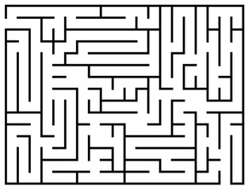



Candy Corn Ring Toss

- Begin at a spot marker and take turns with a partner trying to toss a hoop so it lands around the candy corn (cone) like a ring toss!
- Each partner gets two tries to get their hoop to land around the candy corn.
- Be a good partner and help get the hoop back to them after each attempt.





Spider Hop

- Begin at the number 1 and try to stomp on the spiders while completing the hop scotch board!
- Take turns with a partner if sharing the same hop scotch board.
