Station 1: SNOW SCULPTURES

EQUIPMENT: 30-50 Plastic Cups, YouTube Demonstration

SET-UP: Neatly scatter cups into a nice pile.

OBJECTIVE: Build a creative sculpture using the cups.

DESCRIPTION: Use the cups to create your sculpture.

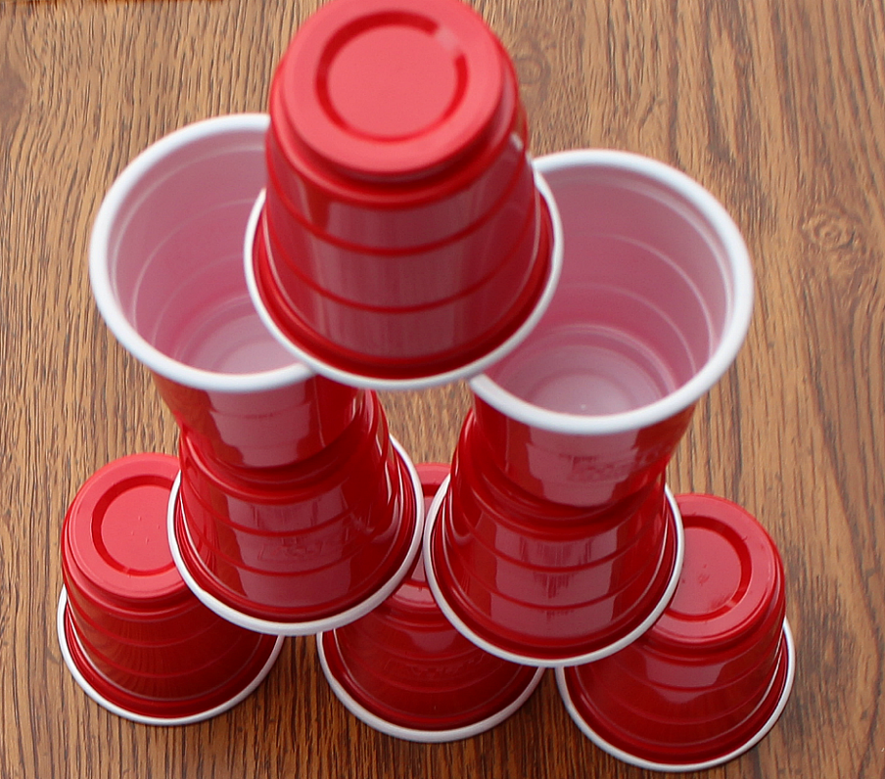
Station 2: GINGERBREAD RUN

Equipment: Gingerbread cutouts, 2 spots, YouTube Demonstration

Set-up:
- Gingerbread cutouts upside down 15 paces away from the 2 spots.
- If playing with a partner, each partner has a spot for collecting gingerbread men.
- If playing solo, alternate spots as you collect gingerbread men.

Objective: To collect enough gingerbread points to beat the opponent.

Description:
- Use the movements below to collect a gingerbread cutout piece.
- Take turns placing the gingerbread pieces onto each of the spots.
- Once all gingerbread pieces are collected select a pile from one of the spots and count the number of buttons each gingerbread man has. Now, double this number to get your score.
- Take the pieces from the other spot and count the number of wiggly stripes piece has. This total represents your opponent’s score.
- If your score is higher, celebrate with 5 star-jumps. If your score is lower, hold a plank for a 10-count.

Lap | Movement |  | Lap | Movement
1 | Skip |  | 5 | Hop (Right)
2 | Gallop |  | 6 | Hop (Left)
3 | Jump |  | 7 | Slide (to Right)
4 | Run |  | 8 | Slide (to Left)


Station 3:
MARSHMALLOW MADNESS

Equipment: Bucket (or cup), Fluff Balls (or cotton balls), YouTube Demonstration

Set-up: Place the balls 10 paces away from the bucket.

Objective: To fill your bucket/cup with all the fluff/cotton balls.

Description:
- You are hungry as a bear. Use a bear walk to move to the ball pile.
- Use a finger and thumb to grip a ball then run back and drop this marshmallow into your cup of hot cocoa.
- Repeat the process, but each time you must use a different finger to grip a marshmallow (ex. if you used your index finger and thumb previously, then you can use a pinky and thumb).

Station 4: CANDY CANE LANE

Equipment: 6 Noodles, 6 Spots, YouTube Demonstration

Set-up: Place the spots in a zig-zag pattern. Lay a noodle on each spot.

Objective: To stand a noodle on each spot and move through the obstacle as quickly as possible.

Description:
- You must first get a noodle to stand vertically on each spot.
- Once all 6 noodles are standing, weave through the obstacle making sure not to knock any over.

