WASH WITH WORDS

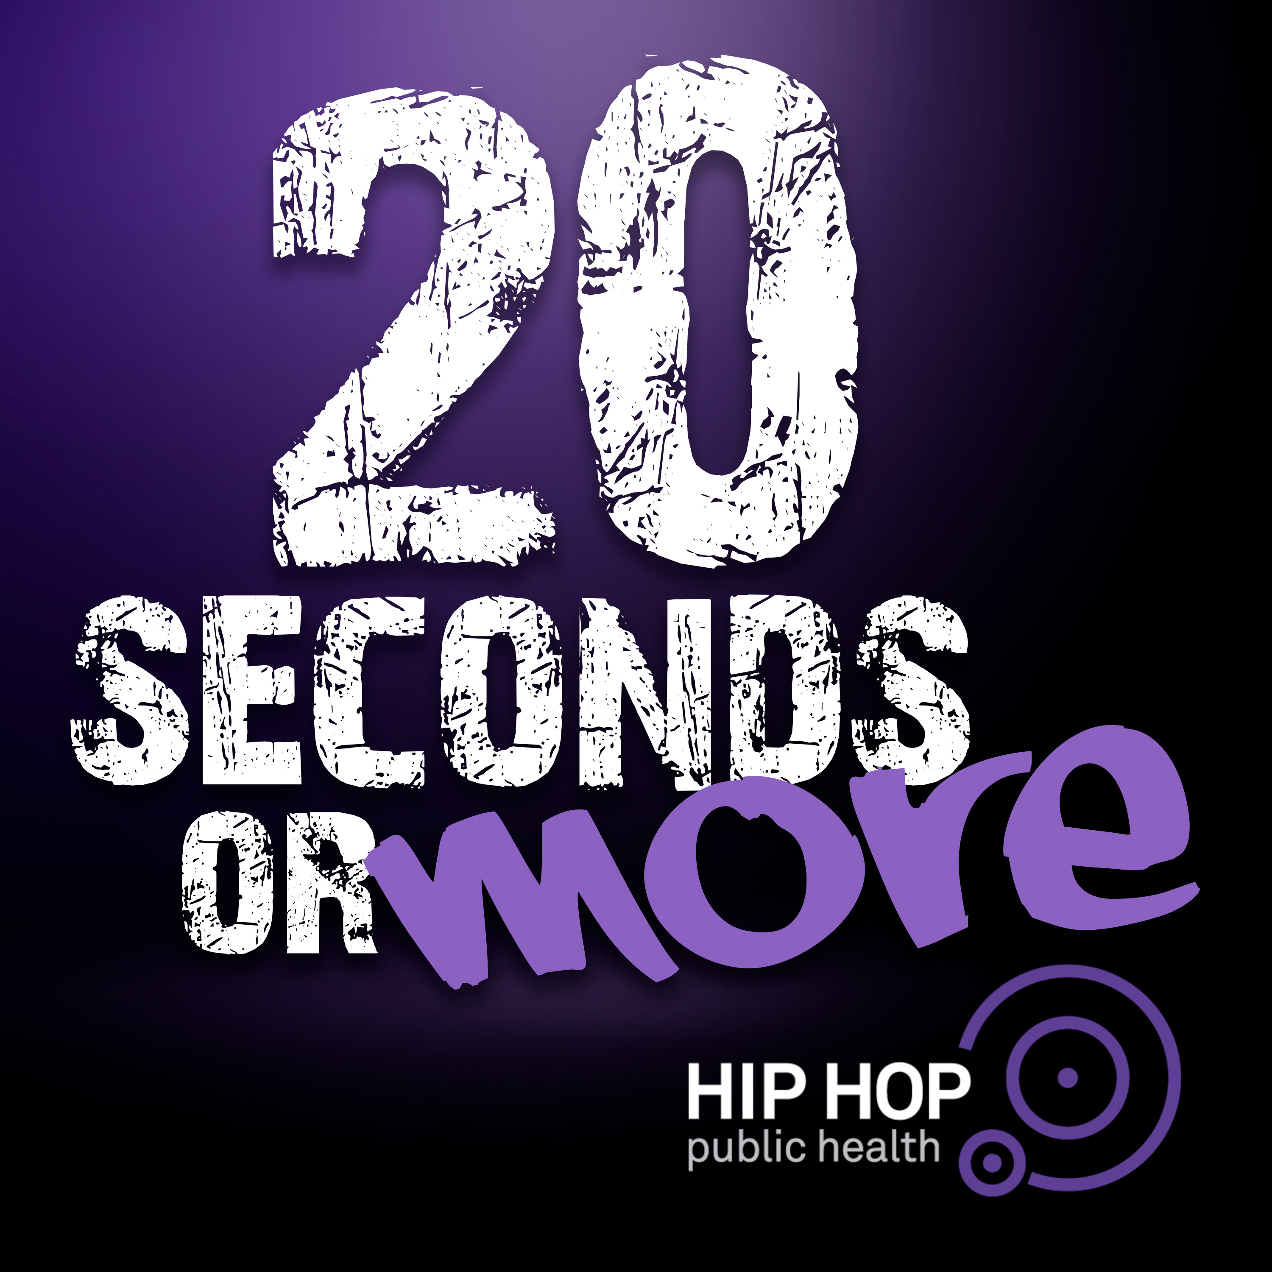
Equipment:
- 20 Seconds or More music file
(Links available below or at HHPH.org)
- Wash with Words Phrases (Below)
- Wash with Words Brainstorming Page

Get the Track… 20 Seconds Or More!
- YouTube
- Spotify
- iTunes
- Apple Music

Activity Procedures:
- Today we’re going to Wash with Words!
- 20 Seconds or More, is a Hip Hop song featuring legendary rapper Doug E. Fresh who co-wrote the song with multi-platinum producer, Artie Green and Gerry Gunn, along with medical oversight from our founder, Dr. Olajide Williams.
- This song was created by Hip Hop Public Health to empower YOU and your family with the right information, tools and resources to help stop the spread of COVID-19.
- Wash with Words is a fun way to interact with this amazing Hip Hop track with self-expressive dance.
Here’s how it works:
- You and a friend or family member will create 8-count dance movements for 4 of the Wash with Words phrases below. There are 8 phases listed, you can choose 4.
- Next, practice your dance moves and use the Brainstorming Page in this packet to create a dance sequence. Take time, practice your moves, and then (if you’re brave) perform them for an audience! Feel like you really have it down? Post your dance using #20SecondsOrMore and tag @HHPHorg and @OPENPhysEd.org

Wash with Words Phrases

Slippery Soap | Big Bubbles | Freezing Water | Angry Wash
Slow Motion Soap | Head Bob Wash Routine | Speed Scrubbing | Happy Wash

