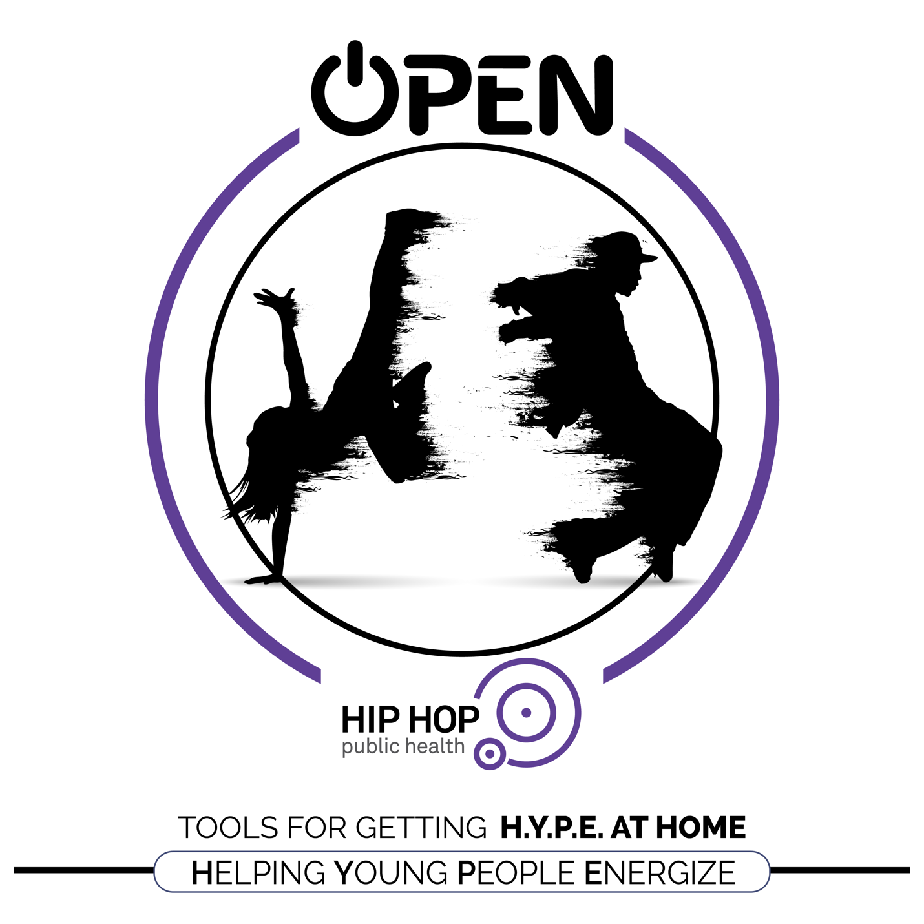

NAME: _________________________ DATE: ___________

This is a 2-week home journaling journey that helps you explore
self-expression and personal fitness through dance.
ELEMENTARY GRADES
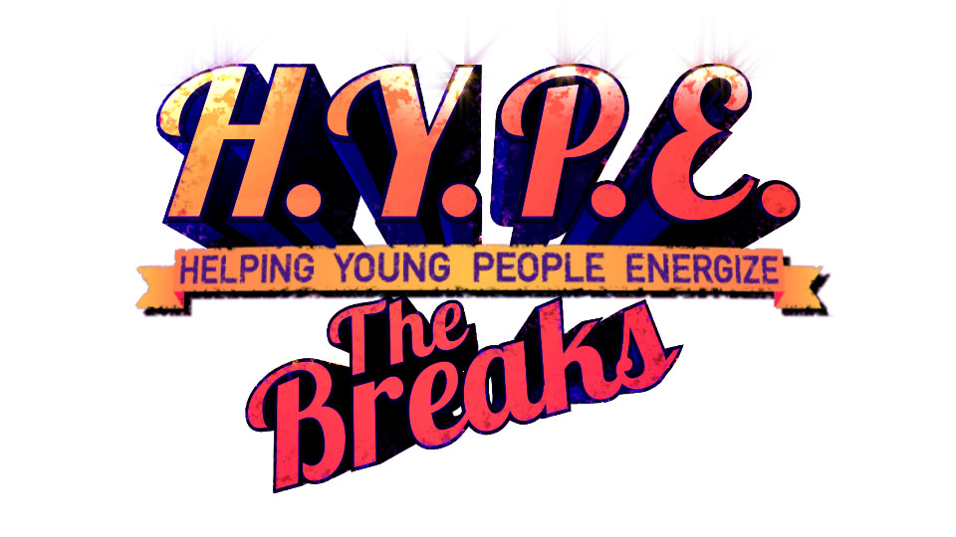
This is a 2-week home study focused on…
- Understanding your emotions and how physical activity and dance can help you feel healthy, happy, and strong.
- Developing an optimistic mindset that will help you learn hard things and give you the power to help others feel optimistic too.
- Staying physically active through dance.

By completing this journal, you will be working toward the following SHAPE America Grade-level Outcomes for Physical Education.

S1.E5 Locomotor: Dance
Standard 1 [E5.3-5] Performs teacher-selected and developmentally appropriate dance steps and movement patterns (3); Combines locomotor movement patterns and dance steps to create and perform an original dance (4); Combines locomotor skills in cultural as well as creative dances (self and group) with correct rhythm and pattern (5).

S2.E4 Movement Concepts: Alignment & muscle tension
Standard 2 [E4.3] Employs the concept of alignment in gymnastics and dance (3a); Employs the concept of muscle tension with balance in gymnastics and dance (3b).

S5.E1 Health
Standard 5 [E1.3-5] Discusses the relationship between physical activity and good health (3); Examines the health benefits of participating in physical activity (4); Compares the health benefits of participating in selected physical activities (5).

S5.E2 Challenge
Standard 5 [E2.3-5] Discusses the challenge that comes from learning a new physical activity (3); Rates the enjoyment of participating in challenging and mastered physical activities (4); Expresses (via written essay, visual art, creative dance) the enjoyment and/or challenge of participating in a favorite physical activity. (5).

DAY 1
Let’s check in BEFORE you dance. How are you feeling today? (Circle all that you feel)

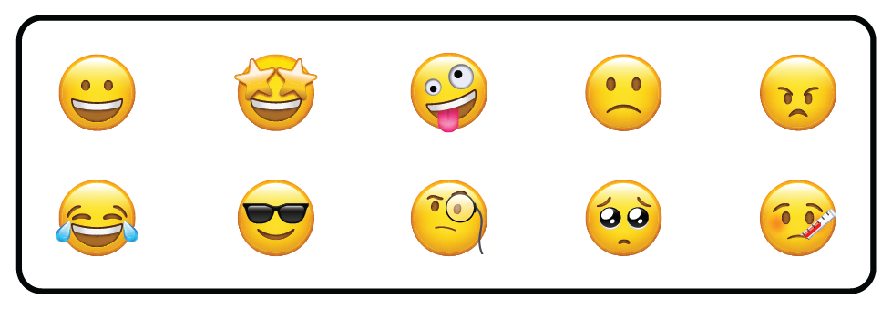

Today, we’re going to learn a new dance and then reflect on how our activity makes us feel. Follow the steps below and then answer the journal questions on the next page.

- Follow along with the video and learn the dance.
- Follow the video and work on memorizing the movements.
(Try the dance at least 2 or 3 times all the way through.)
- When you feel ready, dance to the music only – without the video.

CLICK THE PICTURE TO WATCH THE  VIDEO | 

Today’s focus: Identifying Emotions
It’s not always easy to talk about how we’re feeling. Sometimes we don’t even know how to explain our emotions. This activity is designed to help us build the skill and courage to talk with others about how we’re feeling.

Let’s check in AFTER you dance. How are you feeling now? (Circle all that you feel)

List all of the words that can help describe how you’re feeling?

How did this dance affect the way you’re feeling?

Why do you think it affected you in this way?

You are awesome! Try this dance with a friend or family member.
Make sure to keep moving and learning every day! We are proud of you!

DAY 2
Let’s check in BEFORE you dance. How are you feeling today? (Circle all that you feel)

Today, we’re going to practice the dance that we learned yesterday.
Follow the steps then answer the journal questions on the next page.

- Follow along with the video and practice the dance.
- Follow the video and work on memorizing the movements.
(Try the dance at least 2 or 3 times all the way through.)
- When you feel ready, dance to the music only – without the video.

CLICK THE PICTURE TO WATCH THE
VIDEO

Today’s focus: Self-Confidence
Dance is amazing because every person has a unique style to share with the world. Don’t worry if you don’t look exactly like the dancers on the video. Actually, it’s better if you don’t! Add your style to the moves and appreciate the great things that physical activity does to keep you healthy.

Let’s check in AFTER you dance. How are you feeling now? (Circle all that you feel)

Using only positive words, write a complete sentence that describes your personal dance style.

Using only 3 words, how would you summarize your personal dance style.

Imagine you’re talking to a friend that loves to dance but feels too embarrassed to dance in front of other people. Write 2 or 3 sentences that can encourage your friend to dance with joy and confidence.

You are awesome! Try this dance with a friend or family member.
Make sure to keep moving and learning every day! We are proud of you!

DAY 3
Let’s check in BEFORE you dance. How are you feeling today? (Circle all that you feel)

It’s DIY Dance Day! Today you’ll use what you’ve learned to create your own Cross & Dip dance routine. Follow the steps below.

- Go to the audio track for this dance.
- Use the next page to make notes about different dance moves that you can use to create your own dance routine.
- Create a routine and practice it until you get it the way you want it. Then, teach a friend of family member – dancing is good for EVERYONE!

CLICK THE PICTURE TO HEAR THE AUDIO TRACK | 
Today’s focus: Self-Discipline
Make sure you DIY this dance without giving up. Self-discipline means that you can focus on a task from start to finish, and you’re willing to look for help when you need it. As you practice your dance moves, you’re also practicing self-discipline.

List all of the dance moves you want to use in your DIY dance. It’s okay if they’re not in order.

Practice all of the moves you listed above. Which ones do you like the best?

Now, write your dance moves in order so that someone could read the list and follow along. Practice until you can perform it without looking at the list. Now you’re ready to teach someone else!

Let’s check in AFTER you perform your DIY dance
How are you feeling now? (Circle all that you feel)

DAY 4
Let’s check in BEFORE you dance. How are you feeling today? (Circle all that you feel)

Today, we’re going to learn a new dance and then reflect on how our activity makes us feel. Follow the steps below and then answer the journal questions on the next page.

- Follow along with the video and learn the dance.
- Follow the video and work on memorizing the movements.
(Try the dance at least 2 or 3 times all the way through.)
- When you feel ready, dance to the music only – without the video.

CLICK THE PICTURE TO WATCH THE  VIDEO | 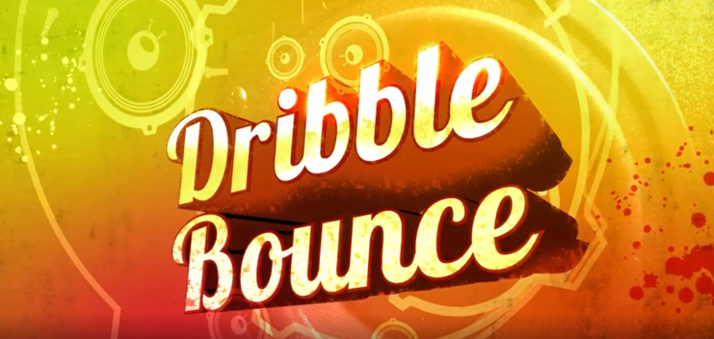

Today’s focus: Impulse Control
When we’re learning something new, we need to stick with it. That means we have to control our impulse to quit. One way to help us do that is by setting goals and tracking our progress toward that goal in small steps.

Let’s check in AFTER you dance. How are you feeling now? (Circle all that you feel)

What is a goal?

How would you write a goal related to learning a new dance?

List 3 small steps you could take toward your goal?

You are awesome! Try this dance with a friend or family member.
Make sure to keep moving and learning every day! We are proud of you!

DAY 5
Let’s check in BEFORE you dance. How are you feeling today? (Circle all that you feel)

Today, we’re going to practice the dance that we learned yesterday.
Follow the steps then answer the journal questions on the next page.

- Follow along with the video and practice the dance.
- Follow the video and work on memorizing the movements.
(Try the dance at least 2 or 3 times all the way through.)
- When you feel ready, dance to the music only – without the video.

CLICK THE PICTURE TO WATCH THE  VIDEO | 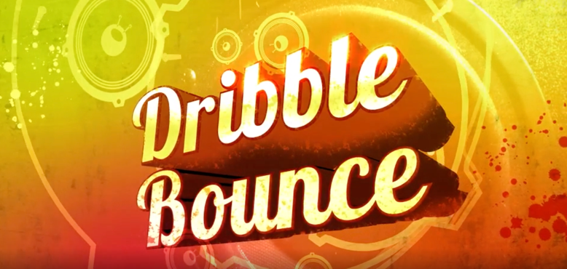

Today’s focus: Self-Motivation
When we’re learning by ourselves or in small groups, we need self-motivation. Optimism is really important as we work to motivate ourselves. That mean, we try to look on the bright side of things and find the good in what we’re doing.

Let’s check in AFTER you dance. How are you feeling now? (Circle all that you feel)

List all of the good things about learning a new dance.

How is learning a new dance related to your health? How does dancing keep you healthy?

Imagine you’re talking to a friend that loves to dance but is discourage and wants to quit learning new dances. Write 2 or 3 sentences that can motivate your friend to keep learning new dances.

You are awesome! Try this dance with a friend or family member.
Make sure to keep moving and learning every day! We are proud of you!

DAY 6
Let’s check in BEFORE you dance. How are you feeling today? (Circle all that you feel)

It’s DIY Dance Day! Today you’ll use what you’ve learned to create your own Bounce dance routine. Follow the steps below.

- Go to the audio track for this dance.
- Use the next page to make notes about different dance moves that you can use to create your own dance routine.
- Create a routine and practice it until you get it the way you want it. Then, teach a friend of family member – dancing is good for EVERYONE!

CLICK THE PICTURE TO HEAR THE AUDIO TRACK | 
Today’s focus: Growth Mindset
With dance, and in many areas of life, trying to do something great is more important that doing something perfectly. When you try to be great and make mistakes, you learn and grow. When you keep doing easy things perfectly, your body and brain can’t get stronger and smarter.

Creating and learning new dances can be hard. List one other thing that you learned even though it was hard.

Write 3 positive words that you can say to yourself when you’re trying to do something that is difficult.

1) 2) 3)

Now, use the space below to write down your new dance moves. Practice until you can perform it without looking at the list. Now you’re ready to teach someone else!

Let’s check in AFTER you perform your DIY dance
How are you feeling now? (Circle all that you feel)

DAY 7
Let’s check in BEFORE you dance. How are you feeling today? (Circle all that you feel)

Today, we’re going to learn a new dance and then reflect on how our activity makes us feel. Follow the steps below and then answer the journal questions on the next page.

- Follow along with the video and learn the dance.
- Follow the video and work on memorizing the movements.
(Try the dance at least 2 or 3 times all the way through.)
- When you feel ready, dance to the music only – without the video.

CLICK THE PICTURE TO WATCH THE  VIDEO | 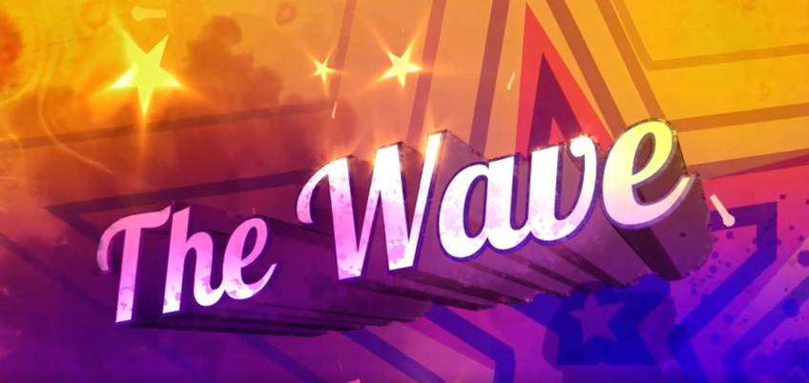
Today’s focus: Stress Management
Did you know dancing can send waves of healthy chemicals into your brain and body to help you feel happy and less stressed? Well, it’s true. The physical activity of dance mixed with the mental focus that dance requires can help you de-stress when you need it most.

Let’s check in AFTER you dance. How are you feeling now? (Circle all that you feel)

How can you recognize stress in your body?

What does stress management mean?

How is physical activity related to stress management?

You are awesome! Try this dance with a friend or family member.
Make sure to keep moving and learning every day! We are proud of you!

DAY 8
Let’s check in BEFORE you dance. How are you feeling today? (Circle all that you feel)

Today, we’re going to practice the dance that we learned yesterday.
Follow the steps then answer the journal questions on the next page.

- Follow along with the video and practice the dance.
- Follow the video and work on memorizing the movements.
(Try the dance at least 2 or 3 times all the way through.)
- When you feel ready, dance to the music only – without the video.

CLICK THE PICTURE TO WATCH THE  VIDEO | 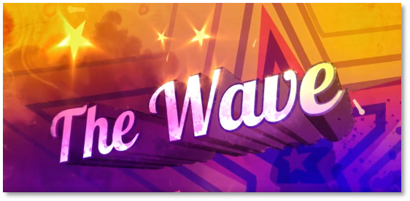

Today’s focus: Relationship-building
Helping our friends and family when they need it is an important part of building good relationships. Now that we know that dance helps us feel good with less stress, is there someone in your life that could use a little help relaxing? Great! Ask them to learn this dance with you!

Let’s check in AFTER you dance. How are you feeling now? (Circle all that you feel)

How can you tell when a friend or family member needs help?

What are 3 things that you’ve done this year to help someone else?

If you were feeling stressed about something, how would it make you feel if someone asked you to do something active and fun? Why do you think it would make you feel that way?

You are awesome! Try this dance with a friend or family member.
Make sure to keep moving and learning every day! We are proud of you!

DAY 9
Let’s check in BEFORE you dance. How are you feeling today? (Circle all that you feel)

It’s DIY Dance Day! Today you’ll use what you’ve learned to create your own Flow dance routine. Follow the steps below.

- Go to the audio track for this dance.
- Use the next page to make notes about different dance moves that you can use to create your own dance routine.
- Create a routine and practice it until you get it the way you want it. Then, teach a friend of family member – dancing is good for EVERYONE!

CLICK THE PICTURE TO HEAR THE AUDIO TRACK | 
Today’s focus: Communication
As you create and practice this dance, make a communication plan for teaching it to someone else. It’s more fun to learn when your teacher uses positive encouragement along with corrective feedback. Help your students learn through the power of positive language.

List all of the positive words that you think can help you teach your dance to a friend or family member.

Why are positive words important when you’re talking with someone?

Now, use the space below to write down your new dance moves. Practice until you can perform it without looking at the list. Now you’re ready to teach someone else!

Let’s check in AFTER you perform your DIY dance
How are you feeling now? (Circle all that you feel)

DAY 10
Let’s check in BEFORE you dance. How are you feeling today? (Circle all that you feel)

It’s Dance Party Day! It’s time to celebrate!

Go to any of the dance videos or audio tracks in this HYPE at Home journal and express yourself! Get a friend or family member to join you and make it a party!

Today’s focus: Optimism
Did you know that happiness and optimism are contagious? Yep, contagious in a good way. Every person’s brain has millions of mirror neurons that tell our brains to smile when we see another person smile. When we watch a person dance, mirror neurons tell our brains that our bodies can dance too! Why not smile and dance at the same time? It’s a great way to help our friend and family catch some happiness and optimism!

Final Reflection

List as many words as you can that can help you describe how learning HYPE the Breaks dances made you feel.

How can you use what you’ve learned in this journal to help you stay optimistic when learning new things?

Use the space below to write anything that you’re thinking or feeling right now.

Let’s check in AFTER your Dance Party!
How are you feeling now? (Circle all that you feel)

