FUN WITH SCOOPS

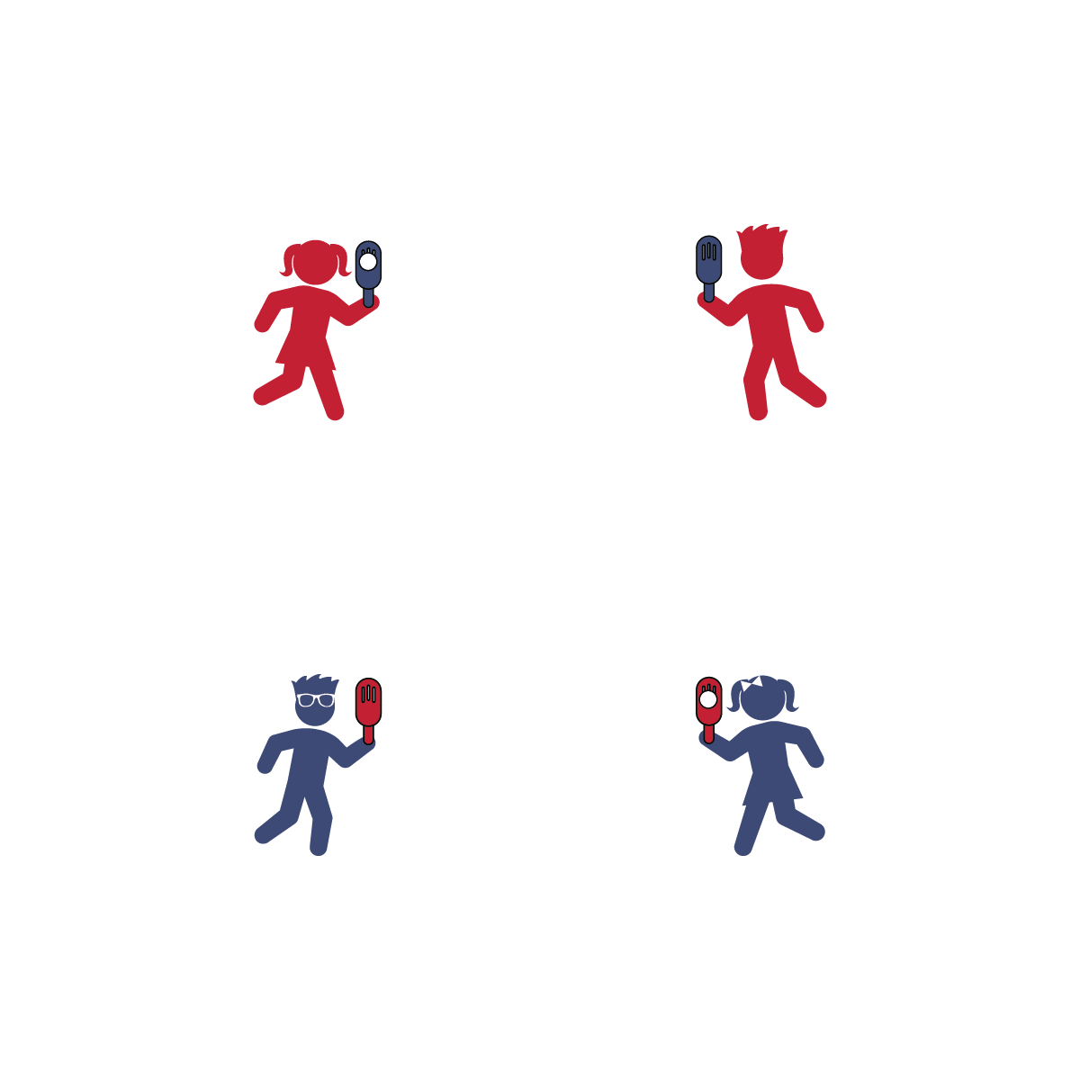



Activity Procedures:
- Today’s activity is Fun with Scoops. We will be working on throwing and catching a ball using a Fun-Air Scoop.
- Activity 1: Partner 1 will toss the ball underhand, and Partner 2 will catch it in the scoop. Challenge each other to catch 10 good tosses, and then switch roles.
- Activity 2: Partner 1 holds the scoop with the head up at shoulder height, the open face toward the target, and the ball inside the scoop. Partner 1 will toss the ball using the scoop, and Partner 2 will catch it in her/his hands. Challenge each other to catch 10 good tosses, and then switch roles. Focus on soft and controlled tosses that can be caught.
- Activity 3: Both partners will have a scoop. Practice passing the ball back and forth using only the scoop to throw and catch. Add a challenge by increasing the distance between partners.

Tips:
- Before tossing from the scoop to a partner, try tossing the ball against a wall. Continue against the wall until the tosser can demonstrate safe control and speed.
Equipment:
- 1 Fun-Air Scoop per player
- 1 ball per team of 2 players

Set-Up:
- Find an open space with enough room to play catch.
- Each player with 1 scoop, and each team with 1 ball.
- Elevate Your Game: Two cups of broccoli contains more Vitamin C than 2 oranges, and it contains about the same amount of Calcium as a cup of whole milk. Increase your Vitamin C and Calcium game with broccoli at lunch or dinner.
- I will demonstrate cooperation by safely practicing throwing and catching with a friend.
- Control Your Scoop
- Control the Ball
- Step to Target with Opposite Foot
- Keep Your Eye on the Ball

