LOCOMOTOR SHAPES

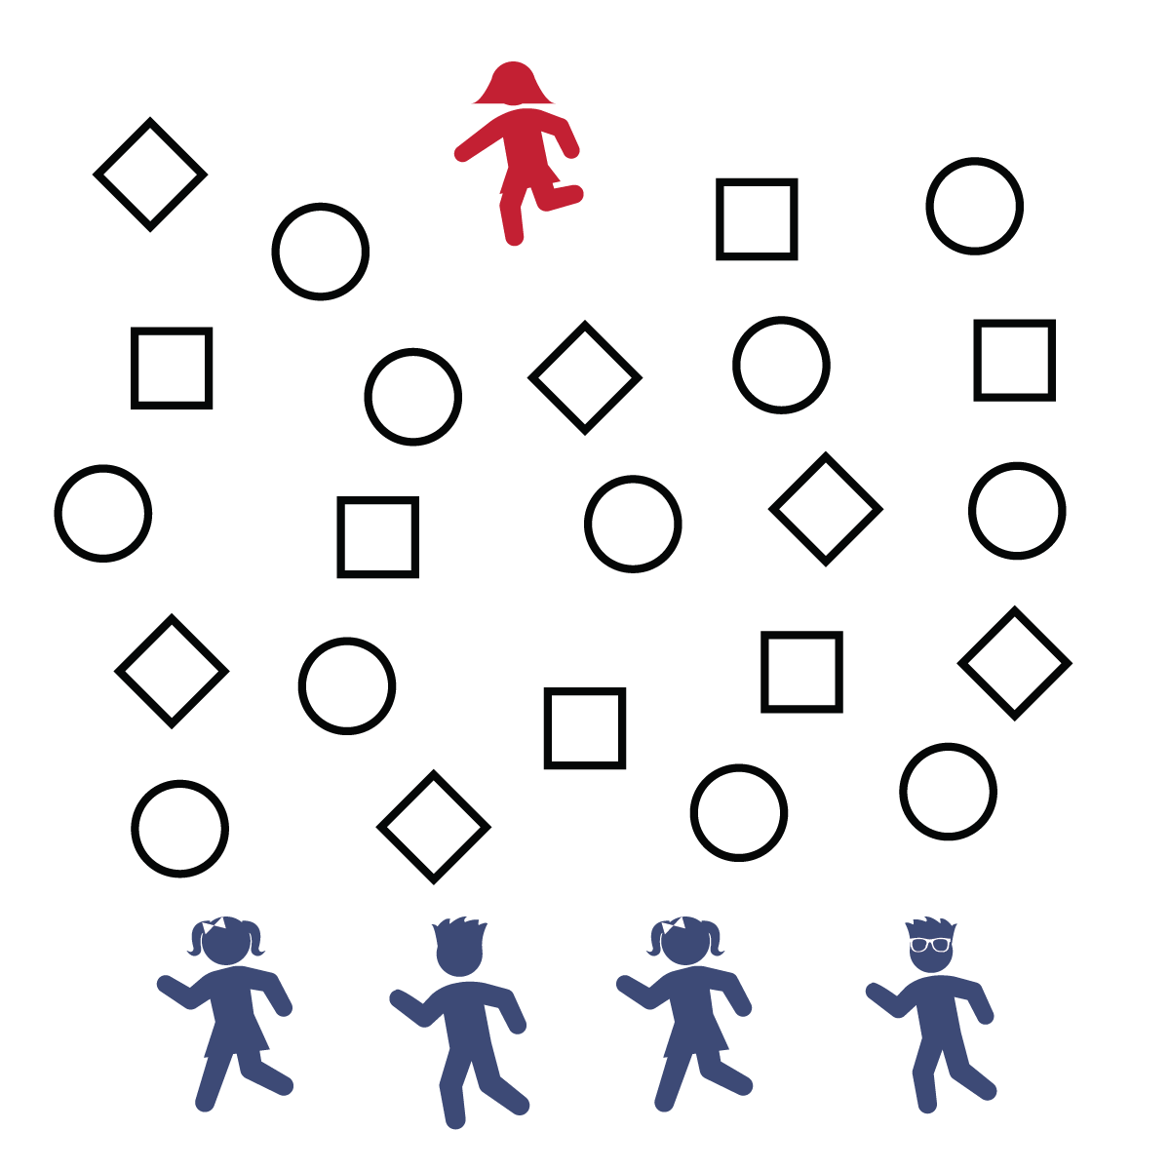



Equipment:
- Sidewalk chalk
- Large concrete or blacktop area (like a driveway)

Set-Up:
- Create a large activity area by drawing 20–30 circles and 20–30 squares throughout general space. Leave at least 1 foot in between each shape.
- One tagger will begin on one side of the area. The rest of the players line up on the opposite side.
Activity Procedures:
- Today activity is call Locomotor Shapes. It’s a tag game with jumping, hopping, and leaping. The object of the game is for all the players to get to the other side of the area without getting tagged.
- Designate 1 player to be the tagger. The tagger will start on 1 side of the area, and all other players start on the opposite side of the playing area. To begin, the tagger will say, "READY, SET, GO!"
- To move, the tagger and all other players must jump, hop, or leap and land correctly from shape to shape. You must jump on squares with a 2-foot landing. You can hop or leap onto a circle with a 1-foot landing.
- When a player is tagged, start the game over. The person who was tagged will be the new tagger. If all players cross without getting tagged, designate a new tagger and play again.

Tips:
- Think safety first: Don’t try to land on a shape if another player is jumping or hopping onto that same shape.
- Work on bending knees, swinging arms, and building momentum for longer jumps and hops.
- Balance Your Moves: There are lots of ways to stay healthy, and balance is important. You rely on balance when you are hopping on 1 foot, and having balance on your plate is also an important step toward healthy eating. Choose a variety of foods from all the food groups while minimizing fats and oils. Good nutritional balance will keep your body strong and healthy.

- I will move safely, following the rules of the game.
- Land Soft by Bending Knees
- Tag Soft on Shoulders Only

