BLINDFOLD BUILDING

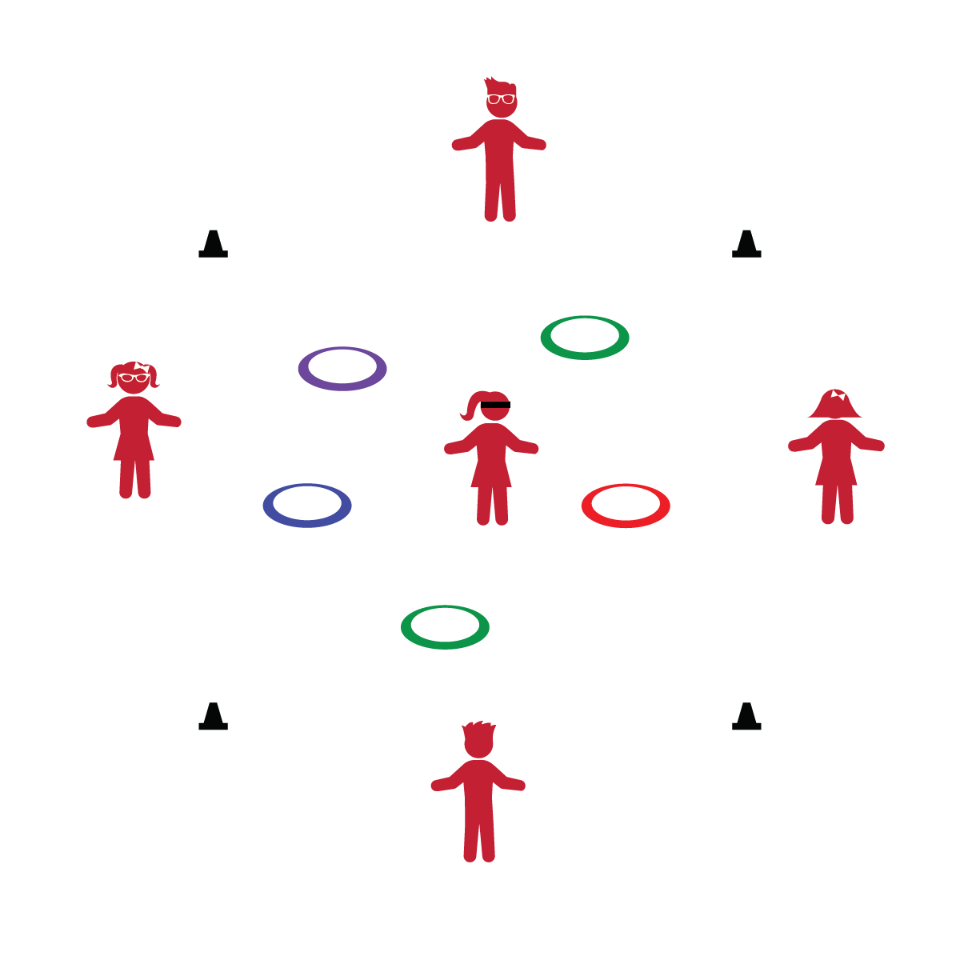

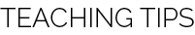

Activity Procedures:
- Today’s activity is call Blindfold Building. The group will use positive communication to guide the blindfolded player through the play area to collect all the hoops.
- Only the blindfolded player may be inside your team’s play space. The other team members must remain outside the play space.
- The group may move around the outside of the play space as needed to help guide the blindfolded player safely to the hoops and assembly area.
- Once the blindfolded player collects all the hoops, the other players will instruct her/him to build a hula hut.

Tips:
- Keep players safe by making sure they stay in bounds.
- Keep the activity area quiet during this activity so teams can communicate clearly and effectively.
- If a player doesn't wish to be blindfolded, respect that choice.
Equipment:
- 5 hula hoops per team
- 1 blindfold per team per team
- 4 cones or spot markers per team

Set-Up:
- Create an 8’x8’ play space (1 per team) using cones or spot markers.
- Scatter hoops within the play space.
- Create teams of 2-5 players.
- Teams stand outside of the play space with 1 player wearing blindfold.
- Stay Inside Boundaries
- Blindfolds are Optional
- Think “Safety First”
- Did You Know? An avocado is high in potassium and low in sugar! Avocados contain 14% of your daily recommendation for potassium. AND, avocados are delish!
- I will demonstrate communication, cooperation, and trust with others.

