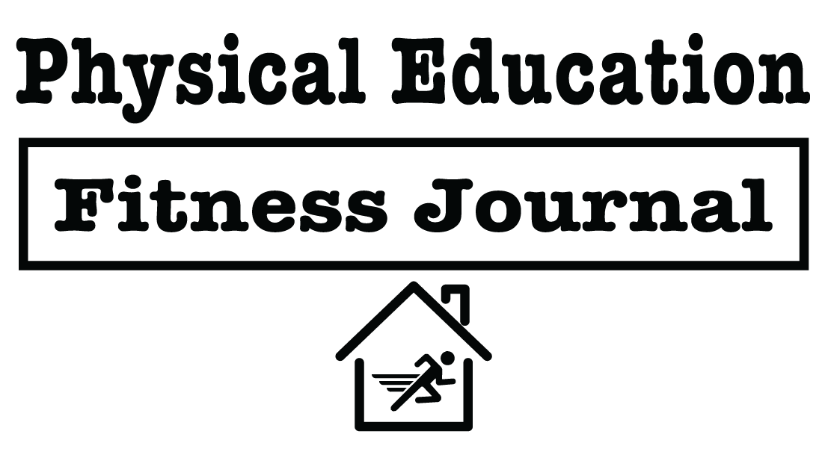

Name: _____________________________________ Date: __________________________
This fitness journal is your instructional guide through a 2-week wellness home study. It has been designed with a focus on the following core competencies for social and emotional learning – Self-Awareness and Self-Management.

In addition, you will be working toward physical education grade-level outcomes in the areas of fitness knowledge and personal and social responsibility.

To receive credit for this assignment, follow the instructions on each page, complete the exercises and writing prompts, and then return your finished journal to your physical education teacher.

Focused Alignments:
Core SEL Competencies | casel.org
Grade-level Outcomes | shapeamerica.org


Featuring Resources By:

This is a 2-week home study focused on…
- Understanding self-awareness and self-management as it relates to physical activity, goal setting, and stress management
- Exploring personal thoughts and emotions as they relate to physical activity and examine how these thoughts affect our behaviors and routines
- Achieving personal activity goals aimed at reducing stress and boosting our body’s ability to fight disease

There are 3 components to this journal.
- First, you will complete daily activity challenges designed to prepare our minds for optimal performance and creativity.
- Second, you will use Tabata-style activity intervals and/or dance breaks to help you progress toward a daily physical activity goal of 60 minutes of moderate to vigorous physical activity.
- Third, you will complete short journaling exercises focused on developing social and emotional competencies.

Your 2-week SMART goals.
A SMART goal is Specific, Measurable, Achievable, Realistic, and Time-bound.

- SMART GOAL 1: During the next two weeks, I will be physically active for at least 60 minutes per day for a minimum of 12 of 14 days. I will track my activity using the activity log provided in this journal.
- SMART GOAL 2: During the next two weeks, I will complete all of the writing prompts included in this journal. Each prompt will help me explore physical and emotional well-being concepts.

Physical Activity Log
Use the activity log to track your progress. Remember, activity minutes add up. It’s okay to break your total activity into smaller chunks of movement.

Week 1:
Day | Activity 1 | Activity 2 | Activity 3 | Total
Sample Day | Daily Challenge  15 Mins | Tabata  15 Mins | Walk with Friends 30 minutes | 60 minutes
Day 1
Day 2
Day 3
Day 4
Day 5
Day 6
Day 7

Week 2:
Day | Activity 1 | Activity 2 | Activity 3 | Total
Sample Day | Daily Challenge  15 Mins | Tabata  15 Mins | Walk with Friends 30 minutes | 60 minutes
Day 1
Day 2
Day 3
Day 4
Day 5
Day 6
Day 7

Daily Activity Challenges
Complete each challenge. When finished, mark an X next to that day’s challenge.
Day | Challenge | Complete ?
Sample Day | How many jumping jacks can you do in 15 minutes? Do your ‘jacks in sets of 25 with a break in between. | X
Day 1 | Visit Darebee.com and complete the  Workout of the Day.
Day 2 | Make 3 sock balls by balling up your socks – duh… Grab an adult and search “learn to juggle” on YouTube. Work for 15 minutes and make progress.
Day 3 | Grab an invisible jump rope and create a routine that includes at least 4 different “tricks.”
Day 4 | Wall Push-ups are just like push-ups but are done standing against a wall. Do 10 sets of 10.
Day 5 | Play 10 games Rock Paper Scissor with a friend. The winner of each game picks an exercise for both of you to complete.
Day 6 | Squat Stare Challenge. Squat position facing a friend. Have a staring contest. The winner picks an exercise for both to complete. No blinks or smiles
Day 7 | Visit www.hhph.org/resources/flow/  And complete this HYPE the Breaks routine.
Day 8 | Remember how many jumping jacks you did in 15 minutes? It’s time to break your record! Do your ‘jacks in sets of 25 with a break in between.
Day 9 | Practice makes perfect! Grab those 3 sock balls and work on your juggling for another 15 minutes.
Day 10 | Visit Darebee.com and complete the  Workout of the Day.
Day 11 | How many jumping jacks can you do in 15 minutes? Do your ‘jacks in sets of 25 with a break in between.
Day 12 | Play 10 games Rock Paper Scissor with a friend. The winner of each game picks an exercise for both of you to complete.
Day 13 | Squat Stare Challenge. Squat position facing a friend. Have a staring contest. The winner picks an exercise for both to complete. No blinks or smiles
Day 14 | Visit www.hhph.org/resources/to-the-core/  And complete this HYPE the Breaks routine.

Let’s H.Y.P.E. the breaks!
Hip Hop Public Health is an organization dedicated to helping kids and their families live health and active lives. They’ve created a video dance series called HYPE the Breaks that you can use at home to stay active. Here’s how you can find a dance that you like.

- Visit www.hhph.org
- Click on the “RESOURCES” link in the top menu.
- Use the Filter and Sort tools on the left of the window.
- Check “HYPE Breaking It Down” and “HYPE the Breaks Vol. 1”
- Click on and follow then along with one of the many videos.

TABATA Time!
What is Tabata Training?
- Tabata training was created by a Japanese scientist named Dr. Izumi Tabata.
- True Tabata workouts combine 20 seconds of vigorous activity with 10 seconds of rest in between each set.
- We may adjust our timing and intensity throughout the module, but it’s important to understand the history behind our workouts.
- Dr. Tabata’s research showed that even 4-minute workouts using his timing formula can have positive results on a person’s overall fitness.

We’ll focus on 2 types of Tabata activity routines – One and Done, and Double or Nothing. Then, you can use the blank routine chart to create your own workout.

One and Done
This format is called “one & done” because each
exercise is only done 1 time during the routine.

Set # | Exercise Name | Interval Start
1 | Jumping Jacks (20 seconds)  Rest 10 seconds | 0:00
2 | Lunges (20 seconds)  Rest 10 seconds | 0:30
3 | Hold Plank Position (20 seconds)  Rest 10 seconds | 1:00
4 | Invisible Jump Rope (20 seconds)  Rest 10 seconds | 1:30
5 | Squats (20 seconds)  Rest 10 seconds | 2:00
6 | Plank Leg Raises (20 seconds)  Rest 10 seconds | 2:30
7 | Jog in Place with High Knees (20 seconds)  Rest 10 seconds | 3:00
8 | Plank Arm Raises (20 seconds)  Rest 10 seconds | 3:30

Double or Nothing
This format is “Double or Nothing” because each exercise is done twice in a row.

Set # | Exercise Name | Interval Start
1 | Lunges (20 seconds)  Rest 10 seconds | 0:00
2 | Lunges (20 seconds)  Rest 10 seconds | 0:30
3 | Hold Plank Position (20 seconds)  Rest 10 seconds | 1:00
4 | Hold Plank Position (20 seconds)  Rest 10 seconds | 1:30
5 | Squats (20 seconds)  Rest 10 seconds | 2:00
6 | Squats (20 seconds)  Rest 10 seconds | 2:30
7 | Jumping Jacks (20 seconds)  Rest 10 seconds | 3:00
8 | Jumping Jacks (20 seconds)  Rest 10 seconds | 3:30

Create Your Own
Create your own routine in the chart below. Looking for good exercises?
Visit www.darebee.com/video.html for a library of exercise videos.

Set # | Exercise Name | Interval Start
1 | Exercise Name: ________________________ (20 seconds)  Rest 10 seconds | 0:00
2 | Exercise Name: ________________________ (20 seconds)  Rest 10 seconds | 0:30
3 | Exercise Name: ________________________ (20 seconds)  Rest 10 seconds | 1:00
4 | Exercise Name: ________________________ (20 seconds)  Rest 10 seconds | 1:30
5 | Exercise Name: ________________________ (20 seconds)  Rest 10 seconds | 2:00
6 | Exercise Name: ________________________ (20 seconds)  Rest 10 seconds | 2:30
7 | Exercise Name: ________________________ (20 seconds)  Rest 10 seconds | 3:00
8 | Exercise Name: ________________________ (20 seconds)  Rest 10 seconds | 3:30

Journaling Exercises
Throughout this 2-week course you will complete journaling exercises on all of the odd-days. On the even days, you will use calming music to help you clear your mind and focus on your breathing.

Day 1
Write a list of 5 things you can do to help your mind and body relax.
If you could choose one place in the world where you could go to relax, where would it be and why did you choose this place?

Now Breathe
(Visit www.hhph.org/resources/mindful-beats/ for free music to use in this exercise)
- You’re going to practice breathing into your belly.  - Find a comfortable place to lay flat on your back. Place a light object (like a small book) on your belly.  - Close your eyes and focus on breathing. As you inhale and exhale, stay mindful of the position of the object. Is it moving?  - Focus on making the object move up when you inhale and down when you exhale. If the object falls off your belly, simply pick it up and place it back in position. | Did you complete this breathing exercise?  Yes or No

Day 3
Write a list of 5 things that you are grateful for. List people, places, or important events.
Write 3 “Thank You” sentences that you could say to a specific person that you are grateful for. Now, go find that person and read what you wrote.

Now Breathe
(Visit www.hhph.org/resources/mindful-beats/ for free music to use in this exercise)
- It’s time to practice breathing into your belly.  - Find a comfortable place to lay flat on your back. Place a light object (like a small book) on your belly.  - Close your eyes and focus on breathing. As you inhale and exhale, stay mindful of the position of the object. Is it moving?  - Focus on making the object move up when you inhale and down when you exhale. If the object falls off your belly, simply pick it up and place it back in position. | Did you complete this breathing exercise?  Yes or No

Day 5
It’s important to use positive language when we talk to others as well as in our own self-talk. Write 5 positive words or phrases you can use today.
Write a single statement of encouragement to yourself. This statement should encourage you to keep working toward daily activity goals.

Now Breathe
(Visit www.hhph.org/resources/mindful-beats/ for free music to use in this exercise)
- It’s time to practice breathing into your belly.  - Find a comfortable place to lay flat on your back. Place a light object (like a small book) on your belly.  - Close your eyes and focus on breathing. As you inhale and exhale, stay mindful of the position of the object. Is it moving?  - Focus on making the object move up when you inhale and down when you exhale. If the object falls off your belly, simply pick it up and place it back in position. | Did you complete this breathing exercise?  Yes or No

Day 7
List 3 words or phrases that describe how you feel each time you finish being physically active.
Write 3 sentences that you could use to convince a friend or family member to be physically active with you.

Now Breathe
(Visit www.hhph.org/resources/mindful-beats/ for free music to use in this exercise)
- It’s time to practice breathing into your belly.  - Find a comfortable place to lay flat on your back. Place a light object (like a small book) on your belly.  - Close your eyes and focus on breathing. As you inhale and exhale, stay mindful of the position of the object. Is it moving?  - Focus on making the object move up when you inhale and down when you exhale. If the object falls off your belly, simply pick it up and place it back in position. | Did you complete this breathing exercise?  Yes or No

Day 9
List 2 accomplishments that you are proud of.
Choose 1 of those accomplishments and write 3 sentences to yourself describing why you are proud and how that accomplishment will help you in the future.

Now Breathe
(Visit www.hhph.org/resources/mindful-beats/ for free music to use in this exercise)
- It’s time to focus on our breathing without using a moving object.  - Find a comfortable place to lay flat on your back.  - Close your eyes and focus on breathing.  - As thoughts come into your mind – let them come and go. Bring your focus back to your breathing as you inhale, and then clear your mind as you exhale. | Did you complete this breathing exercise?  Yes or No

Day 11
Think of a friend or family member. List 1 of their most recent accomplishments that you admired.
Now, write 3 sentences to your friend or family member describing why you are proud their accomplishment and how you believe that achievement will help them in the future.

Now Breathe
(Visit www.hhph.org/resources/mindful-beats/ for free music to use in this exercise)
- It’s time to focus on our breathing without using a moving object.  - Find a comfortable place to lay flat on your back.  - Close your eyes and focus on breathing.  - As thoughts come into your mind – let them come and go. Bring your focus back to your breathing as you inhale, and then clear your mind as you exhale. | Did you complete this breathing exercise?  Yes or No

Day 13
List 3 benefits of completing this 2-week journaling routine.
Choose 1 of the benefits listed above. How is that benefit related to your emotional health?
Give evidence.

Now Breathe
(Visit www.hhph.org/resources/mindful-beats/ for free music to use in this exercise)
- It’s time to focus on our breathing without using a moving object.  - Find a comfortable place to lay flat on your back.  - Close your eyes and focus on breathing.  - As thoughts come into your mind – let them come and go. Bring your focus back to your breathing as you inhale, and then clear your mind as you exhale. | Did you complete this breathing exercise?  Yes or No

