SUMMER OLYMPIC GAMES PASSPORT
This field day focuses on sports that are included in the Summer Olympic Games. The inaugural Summer Olympics occurred in 1896 in Athens, Greece. Today, students will be visiting different countries where they will be engaged in fun physical activities representing various sports from the Summer Olympics. The students not only will be learning fun facts about the country represented, each class has their own Summer Olympic Games Passport which will be stamped at each country (station) they are visiting. Have fun, and let the games begin!

Station 1: Torch Race Tic-Tac-Toe   | Station 6: Olympic Rings Relay  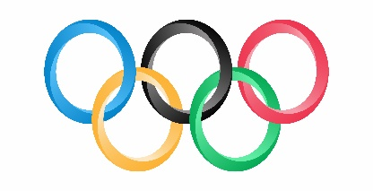
Station 2: Basketball (United States)   | Station 7: Softball (Ireland)  
Station 3: Track & Field (Greece)   | Station 8: Volleyball (Japan)  
Station 4: Football (United Kingdom)   | Station 9: Gymnastics (Germany)  
Station 5: Lacrosse (Canada)   | Station 10: Handball (Denmark)  

