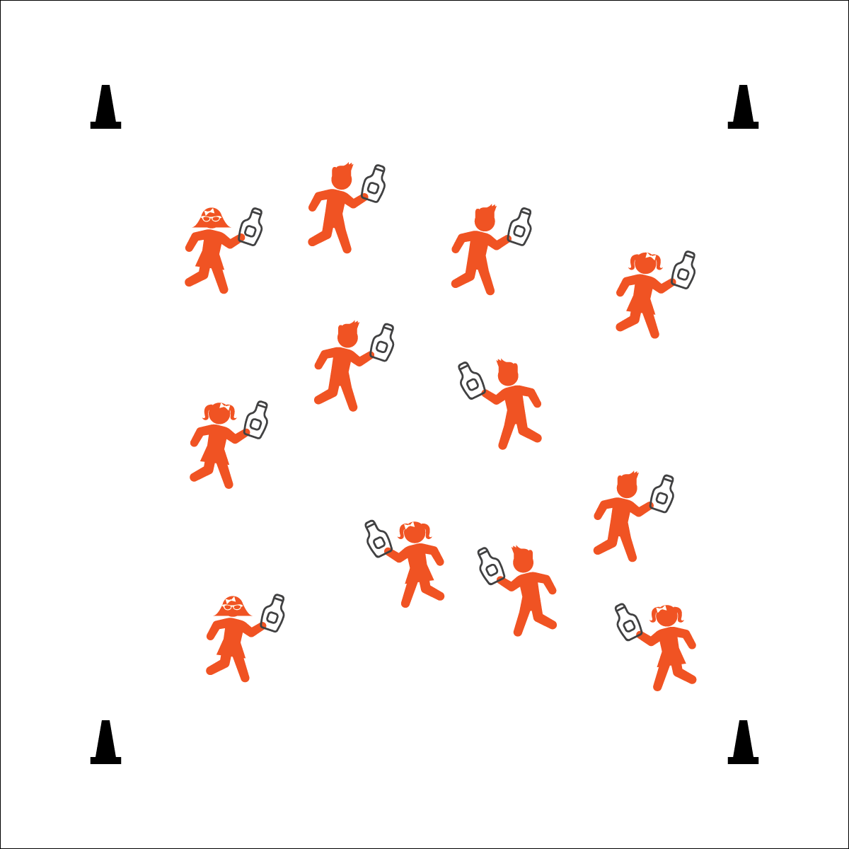


KETCHUP BOTTLE TAG
- Speed Walk Only
- Squirt Below the Neck
- Refill and Go
Equipment:
- 1 clean ketchup bottle (or another clean squeeze bottle) per student
- Students in swimsuits
- 4 cones to create boundaries

Set-Up:
- Create a large activity area using cones.
- Play on a safe surface that does not get slippery when wet.
- Scatter students in the activity area, each student with a clean ketchup bottle full of water.
- Provide a “refill station” with several teachers refilling bottles.
- Personal & Social Responsibility: I will work safely with my classmates by tagging only below the neck.


Activity Procedures:
- This activity is Ketchup Bottle Tag. The object of the game is to tag other players by squirting them with your ketchup bottle.
- On the start signal, begin at a speed-walking pace.
- When your ketchup bottle is empty, move to a refill station and hold plank position as long as you can while your teacher refills your bottle.

Modification:
- Use any type of clean squirt bottles.
- Designate several teachers as Ketchup Bottle Targets. Students only tag teachers.
- Etiquette (K) Recognizes the established protocol for class activities. (1) Exhibits the established protocols for class activities without reminders. (2) Recognizes the role of rules and etiquette in teacher-designed physical activities. (3) Recognizes the role of rules and etiquette in physical activity with peers. (4) Exhibits etiquette and adherence to rules in a variety of physical activities. (5) Critiques the etiquette involved in rules of various game activities. (6) Identifies the rules and etiquette for physical activities/games and dance activities.

