
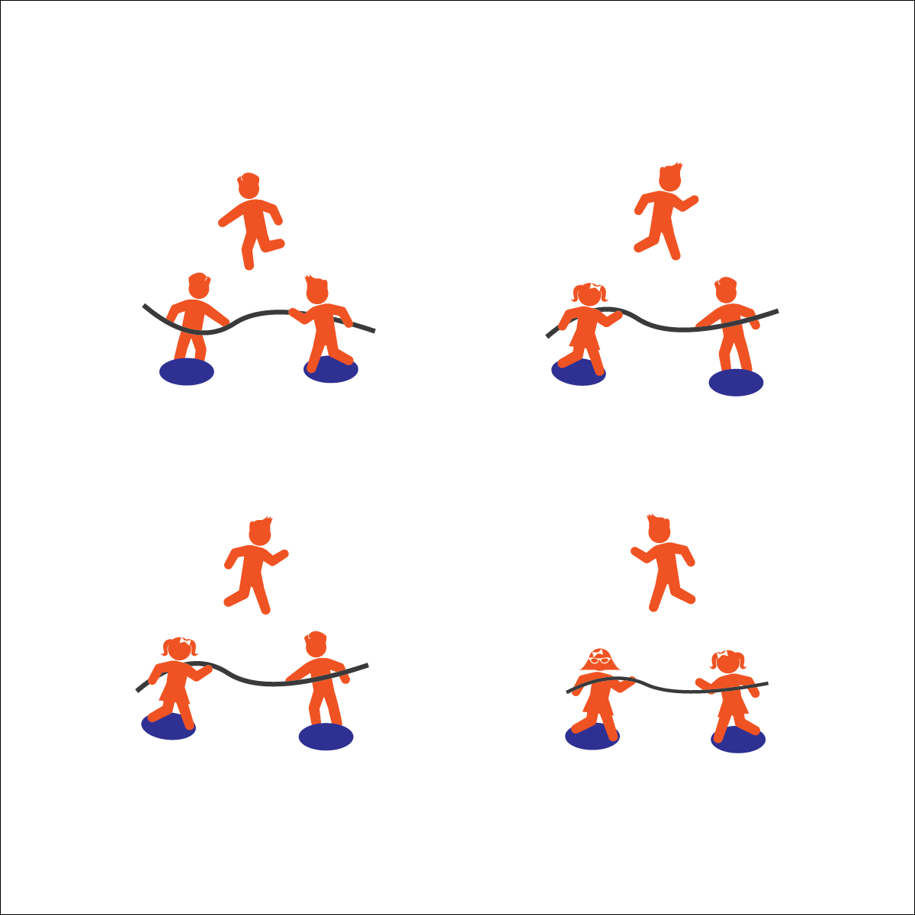
- Etiquette (K) Recognizes the established protocol for class activities. (1) Exhibits the established protocols for class activities without reminders. (2) Recognizes the role of rules and etiquette in teacher-designed physical activities. (3) Recognizes the role of rules and etiquette in physical activity with peers. (4) Exhibits etiquette and adherence to rules in a variety of physical activities. (5) Critiques the etiquette involved in rules of various game activities. (6) Identifies the rules and etiquette for physical activities/games and dance activities.
Activity Procedures:
- Today’s activity is called 1 v 1 Tug to Victory. The object of the activity is for you to pull your opponent off of their base while saying on your base.
- Start the activity with 2 players, each standing on a base and grabbing the rope. Students competing will count down together, "3, 2, 1, GO!" before pulling on the rope.
- If either player's foot touches the ground off their base/platform, or a player lets go of the rope, the round is over. The 3rd person in the group then replaces the player who stepped off the spot.

Modifications:
- Tie a knot on each side of the rope to help students with grip.
- Students must keep 1 or both feet on the spot platform, based on students’ skill and fitness levels.

Equipment:
- 1 7–10' rope (or similar) per group of 3 students
- 2 standing bases per group of 3 students (e.g., large spot markers, 1' x 2' board)

Set-Up:
- Create 1 activity station for every 3 students:
  - 2 standing bases placed so that the distance between them is about 2’ shorter than the rope’s length.
  - 1 rope extending between the bases.
- Create groups of 3, each group at a station.
1 V 1 TUG TO VICTORY


- Personal & Social Responsibility: I will participate respectfully and demonstrate proper etiquette during a competitive activity.
- Bend Knees
- Hold Rope Tightly
- Low Center of Gravity

