MODULE NAME



- Skill: Skill
- Cognitive: Cognitive
- Fitness: Fitness
- Personal & Social Responsibility: PSR

- Teaching cue
- Teaching cue

Equipment:
- Equipment
- Equipment

Set-Up:
- Set-up Instruction
- Set-up instruction

Activity Procedures:
- Activity Procedure
- Activity Procedure

Grade Level Progression:
K: Progression
1st: Progression
2nd: Progression

ACTIVITY NAME
MODULE NAME
ACTIVITY NAME


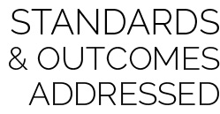


- Challenge Progression

- Developmental Modification

Academic Vocabulary Words

- Standard [outcome code] Standard description

- DOK 1: Question
- DOK 2: Question
- DOK 3: Question

Strategy Focus: How to use the strategy focus.

