 | 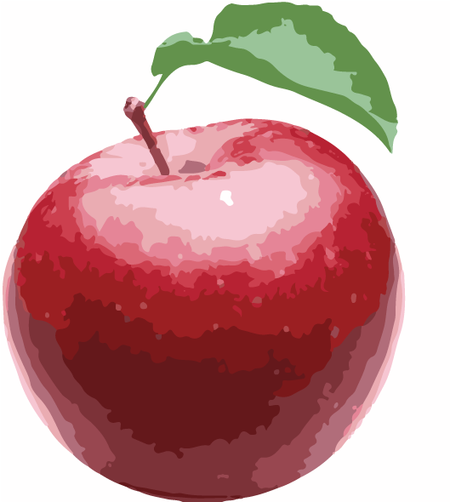
  Apple
  Amount = 1 Medium Apple (raw)
  Nutrient | % of Daily Target
  Total Calories | 72 | 4% limit
  Protein | 0 g | -
  Carbohydrate | 19 g | 15% target
  Dietary Fiber | 3 g | 13% target
  Total Sugars | 14 g | -
  Added Sugars | 0 g | -
  Total Fat | 0 g | -
  Minerals
  Calcium | 8 mg | 1% target
  Potassium | 148 mg | 3% target
  Sodium‡ | 1 mg | 0% limit
  Vitamins
  Vitamin A | 4 µg RAE | 1% target
  Vitamin C | 6 mg | 8% target

 | 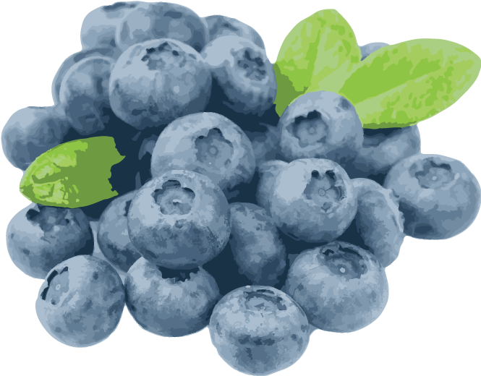
  Blueberries
  Amount = 1 Cup (raw)
  Nutrient | % of Daily Target
  Total Calories | 84 | 4% target
  Protein | 1 g | 2% target
  Carbohydrate | 21 g | 16% target
  Dietary Fiber | 4 g | 14% target
  Total Sugars | 15 g | -
  Added Sugars | 0 g | -
  Total Fat | 0 g | -
  Minerals
  Calcium | 9 mg | 1% target
  Potassium | 114 mg | 2% target
  Sodium‡ | 1 mg | 0% limit
  Vitamins
  Vitamin A | 4 µg RAE | 1% target
  Vitamin C | 14 mg | 19% target

 | 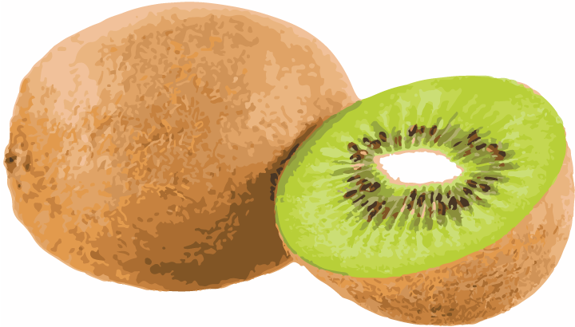
  Kiwi
  Amount = 1 Whole Kiwi (raw)
  Nutrient | % of Daily Target
  Total Calories | 46 | 2% target
  Protein | 1 g | 2% target
  Carbohydrate | 11 g | 9% target
  Dietary Fiber | 2 g | 9% target
  Total Sugars | 7 g | -
  Added Sugars | 0 g | -
  Total Fat | 0 g | -
  Minerals
  Calcium | 26 mg | 3% target
  Potassium | 237 mg | 5% target
  Sodium‡ | 2 mg | 0% limit
  Vitamins
  Vitamin A | 3 µg RAE | <1% target
  Vitamin C | 70 mg | 94% target

 | 
  Oranges
  Amount = 1 Medium Orange (raw)
  Nutrient | % of Daily Target
  Total Calories | 62 | 3% target
  Protein | 1 g | 3% target
  Carbohydrate | 15 g | 12% target
  Dietary Fiber | 3 g | 13% target
  Total Sugars | 12 g | -
  Added Sugars | 0 g | -
  Total Fat | 0 g | -
  Minerals
  Calcium | 52 mg | 5% target
  Potassium | 237 mg | 5% target
  Sodium‡ | 0 mg | 0% limit
  Vitamins
  Vitamin A | 14 µg RAE | 2% target
  Vitamin C | 70 mg | 93% target

